6A – Driving – Lesson 07
Cost & Purchase of Insurance – Total Cost of Loan.

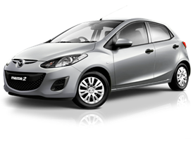
Name: _________________
- Use Redbook to find the value of a 2010 Subaru Impreza WRX STi G3. (Not the private sale price).

- Calculate the 10% deposit?

- How much will you have to borrow?

- Find a good interest rate at. What is the interest rate, what is the period and who is it with?
www.infochoice.com.au/personal-loans/car-loan/interest-rate- comparison/

- Use the spreadsheet to find the monthly repayments.
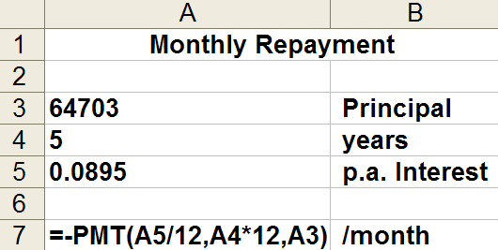
Monthly Repayment = $ _____

- Multiply the Monthly Repayment by the number of months to find the Total Repayments.

- From the Total Repayments subtract the Amount Borrowed to find the Total Interest.

- To find what the interest is as a percentage of the cost of car divide the Total Interest by the Cost of the car and then multiply by 100%.
- Use Redbook to find the value of a car of your choice. (Not the private sale price).

- Calculate the 10% deposit?

- How much will you have to borrow?

- Find a good interest rate at. What is the interest rate, what is the period and who is it with?
www.infochoice.com.au/personal-loans/car-loan/interest-rate- comparison/

- Use the spreadsheet to find the monthly repayments.
Monthly Repayment = $ _____

- Multiply the Monthly Repayment by the number of months to find the Total Repayments.

- From the Total Repayments subtract the Amount Borrowed to find the Total Interest.

- To find what the interest is as a percentage of the cost of car divide the Total Interest by the Cost of the car and then multiply by 100%.

